
General Information for Age, Youth and Performance Levels

Why bother with nutrition?

A balanced, varied diet will help you to achieve their swimming potential

How??

All swimmers need to ensure that they:

- Have the correct amount of energy for growth and development
- Have the right foods to build and maintain strong bones
- Need to be fit and healthy and not ill as much of the time as possible
- Need to recover as quickly as possible
- Have the ability to get to and maintain an appropriate weight
- Be able to concentrate on training and school/work

In other words food and fluids will affect swimmers on a daily basis and shouldn’t be left to chance

E - Energy – get yours from carbohydrates
A - Attitude – a positive attitude towards food choice is essential
T - Tasty – taste is important, always try to make food tasty

W - water is essential for life and for swimming
E – enjoy your food it puts you in a good mood when you enjoy it
L – little and often is the best way too stay energised
L – lots of fruits and vegetables benefits your immune system

S – spend some time planning and organising your snacks and drinks
W – worrying about food at competitions should be a thing of the past
I – Invest in good quality food not cheap convenient food
M – make breakfast an essential part of your preparations

W – water bottles need cleaning regularly
E – Energise to survive the rigours of long hours training
L – learn to rustle up some quick, tasty meals on your own
L – lastly enjoy the occasional treat – you deserve it

AGE GROUP SWIMMERS

Training Diet
Your main challenges are:

- To have variety in your diet (base meal choices around the Balance of Good Health) Plate model curtesy of BNF

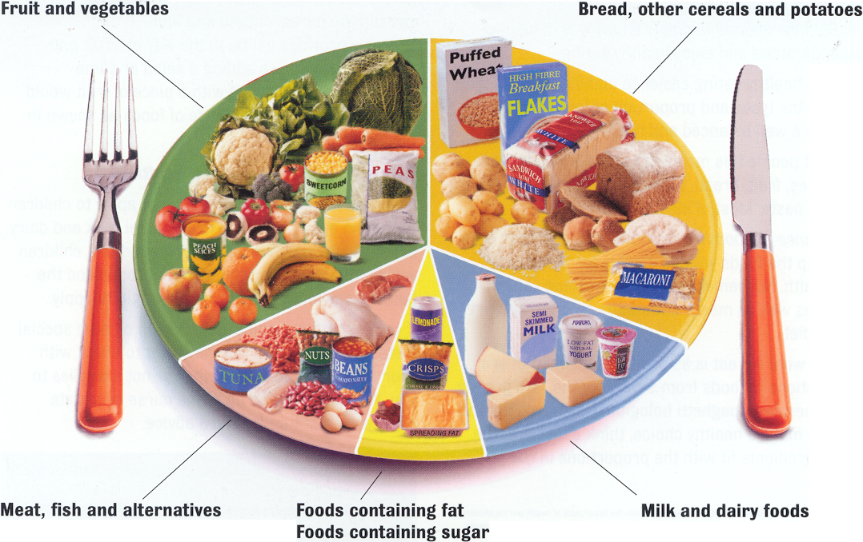
Base meals around starchy, wholegrain (preferably) carbohydrates

Eat at least 5 portions of fruit and vegetables per day (best combination is 3 vegetables and 2 fruit)

Eat 2-3 portions of milk and dairy products daily
Eat 2-3 portions of meat or alternatives daily

Like the oils in fish

Have a low saturated fat intake but include essential fats
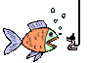
Suitable snacks
Bananas

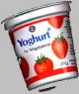

Milkshakes
Yoghurts
Chicken sandwich
Ham roll
Raisins
Sultanas
Teacake
Currant Bun
Scone and jam

- To eat suitable snacks
around training sessions

- To keep as hydrated as possible
Water, weak squash/cordial or an isotonic sports drink
Make sure you like the flavour and remember to keep on topping up

- Set simple nutrition and hydration goals and to self monitor
These could include:
- Eating a good breakfast every day
- Counting up how many portions from each food group you have eaten
- Monitoring your “pee” If you are hydrated it should be pale in colour and lots of it. If it is bright yellow and a small amount you are probably dehydrated and need to drink more
- Planning your snacks and always having the right ones in your bag

YOUTH GROUP SWIMMERS
Your main challenges are:
Taking responsibility for your own

 pre, during and post competition eating and drinking strategy
Do you know how much fluid you need to drink to become as hydrated as possible?
Have you had the right amount of recovery snacks?
pre
 nutrition and hydration plan for travelling

Have you packed sufficient appropriate snacks and drinks for the entire time?
during
Had a good, high carbohydrate breakfast/lunch?
*Are you fully hydrated?

post

A few snacks that travel well
Dried fruit – sultanas/currants/raisins/apricots/dates/prunes/ cranberries/bananas
Juices – cartons of orange/apple/pineapple
Plain biscuits – Ginger nuts/fig rolls/jaffa cakes
Bakery goods – Scotch pancakes/sultana and lemon pancakes/ malt loaf (sliced)/ cinnamon and raisin bagels/ fruit cake/ teacakes/hot cross buns
Bars – Nutrigrain bars/Kellogg’s elevenses or special K bars/ Krispie squares

 acclimatization strategies when competing in extremes of temperatures, humidity and altitude
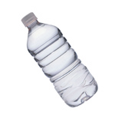
In hot and humid indoor conditions dehydration can occur quickly. Fluid intake should be matched with fluid lost during competition. If properly hydrated prior to event no more than 200-500mls per hour should be sufficient to prevent dehydration

 eating high but non nutritious carbohydrates appropriately
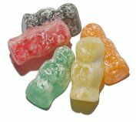
There are occasions when sugary snacks can be consumed. These times are when you need to refuel your glycogen (energy) stores as quickly as possible such as immediately after training or competition. Such snacks should be limited to these times if possible and should not replace more nutritious carbohydrate foods

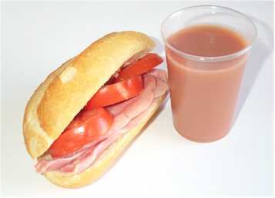

PERFORMANCE GROUP SWIMMERS
Your main challenges are:

 To be able to manipulate the diet for different periods of training and competition

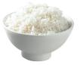
During periods of rest and rehabilitation from injury cut down on portion size of meals and cut out sugary snacks but maintain a balance, varied diet to avoid weight gain

 Be able to choose suitable meals and snacks whilst abroad using local food
Local food can often provide a swimmer with the right nutrients needed. Choose local fruits, vegetables, breads, rice, potatoes, pasta or other grains to provide the carbohydrate energy. Choose grilled, roasted meat, poached, baked or grilled fish. Avoid deep fried dishes, however tempting and do not try anything you do not recognise near to a competition.

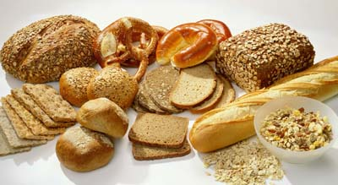

 Maintain an appropriate body composition throughout the year depending on training
Energy in must equal energy out!
Energy our body uses in activity
Energy our body gets from food and drink
 Be knowledgeable about the use and potential risks and benefits of dietary supplements
There are many dietary supplements on the market and some can be useful in helping to increase carbohydrate energy in the form of sports drinks, bars and gels. Be aware of the potential risk of contamination with substances which can produce a positive drugs test – it is very difficult to tell!

